# Theory of IMEI, IMSI and Android (Christian)

A mobile phone connects to a network via a GSM module. A GSM module can host thousands of mobile phones, and it uses two pieces of information to recognize the phones from each other and the IMEI and the IMSI number [5]. The system of IMEI numbers was valid from 2003 [6]. The IMEI number is 14 to 16 digits. As seen on Figure 1, the IMEI number is given, by a set of different digits. The first two digits, marked on the figure with “NN” is the Reporting Body Identifier. The Reporting Body Identifier is a geographic assign code. The next 6 digits, marked with a “XXXXYY” on the figure is the ME Type Identifier. ME stands for Mobile Equipment. It identifies which type of mobile phone it is. The “XXXX” is the original identifiers digits. In the beginning, the YY were set to “00” until they were needed. The “ZZZZZZ” on the figure is the digits for the serial number. The serial number is a unique number for every cellphone of a specific ME type. The last digits is a check digit, which is generated by a function of the other digits, and is uses for verifying the IMEI.



Figure 1: The figure shows the structure of the IMEI number. [6]

The IMEI numbers has been extended by two digits since its first origin.

When the IMEI number is sticks to the cellphone, the IMSI sticks to the SIM-card. The IMSI is similar to IMEI and stands for International Mobile Subscriber Identity. Where the IMEI is like the chassis number of a car, the IMSI is the registration number [8]. The IMSI determines who’s paying for the mobile traffic. The IMSI number is a 14 or 15 digits number, and it is, like the IMEI, generated by a certain system [7]. As seen on Figure 2, the IMSI number start with 3 digits, described as “MCC”. The “MCC” stands for Mobile Country Code, and is a specific code, given for which country the SIM-card is issued. The “MNC” is the Nobile Network Code, and is a code, specific for the operator associated with the SIM-card. It can be 2 or 3 digits long. The last 10 digits is the “MSIN” or the Mobile Subscriber Identification Number. Together, these 14 or 15 digits will be the IMSI.

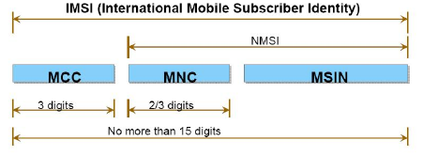

Figure 2: The figure shows the structure of the IMSI number. [7]

When a cellphone connects the mobile network, it will send and identify itself with the IMEI and IMSI.

## Android

Android is an OS for smartphones and tablets developed by Google. Google is a multinational company, which makes a lot of net based solutions like Gmail, Google search, Google Translate etc. Common for all is that it is free. The core of Android is based on a Linux kernel, with GNU software. The Linux kernel is the core of the system, where the OS GNU software is built on. Android uses a built-on version of GNU, with the first release in 2008. Several cellphone manufactures, which uses Android, make their own skin for Android like HTC Sense.

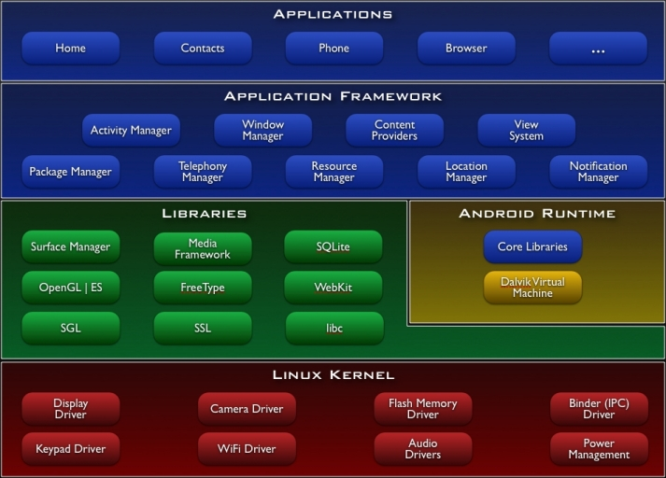

Figur 3: The structure of the Android system.

The structure of Android is described on Figure 3. All the drivers and necessary processes are in the Linux kernel. Then there are a lot of libraries, which the Android runtime use to start up. It is the Android Runtime, which control and coordinate the system, where the libraries are read by the runtime. The kernel is the basic structure, which make the runtime possible to start. Then there is the application framework, and the applications, which make the Apps possible on Android.